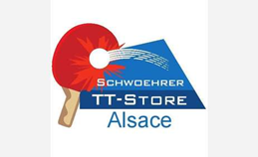
1st Youth Table Tennis International Competition of Mulhouse

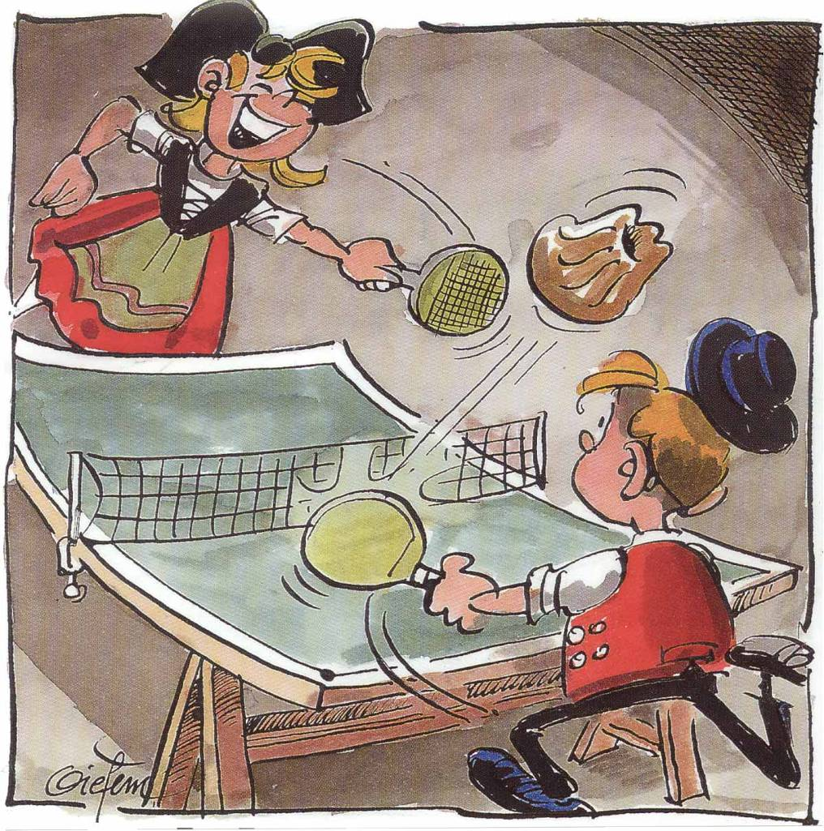

Edition 2018

Edition 2018

At the Sports Centre "Regional Alsace" in MULHOUSE

Saturday, February 24th and Sunday, February 25th 2018

GENERAL ORGANIZATION

1/ PLACE OF COMPETITION

- The competition will take place in the Sports Centre “Regional Alsace” in MULHOUSE, from Saturday, February 24th at 1:00 pm to Sunday, February 25th until 5:00 pm.
- The meeting place for all the delegations is at the Sports Centre “Region Alsace”, 5 rue des Frères Lumière in MULHOUSE (68200), from 10:00 am on.

2/ ACCOMMODATION & CATERING

- For the accommodation, the delegations can choose between the Sports Centre and two different hotels in the surroundings of Mulhouse. The catering will be held on-the-spot in the gymnasium.
- Price for the « competition deal »: from Saturday at 1:00 pm to Sunday until 5:00 pm, hot meals on Saturday evening and Sunday lunchtime + accommodation of Saturday night inclusive.

Prices  Hotels | Delegation  At least 6 players | Individual registration  Hotel + Catering + Tournament registration
Sports Center or Hotel | 75 euros per person | 100 euros per person
Single room | + 25 euros per person | + 25 euros per person

N.B.: It is possible to be in a room with a person from another delegation.

- Possibility to be accommodated from Friday to Saturday on request (≈ 25-30 € per person with breakfast in Sports Center).
- Possibility to have a hot lunch on Saturday on site (12 € per meal).
- Possibility to participate only at the competition (30€ per person).

3/ COMPETITION PROGRAM

- Individual competition by category. The 6 best results, in every category, score points for their delegation.
- The delegations will be composed of 6 to 16 players: you can inscribe 0, 1 or 2 players per category. A delegation has to be represented by a team in at least 6 categories:

PG Boys born in 2009 and after
PF Girls born in 2009 and after
BG Boys born in 2007 and 2008
BF Girls born in 2007 and 2008
MG Boys born in 2005 and 2006
MF Girls born in 2005 and 2006
CG Boys born in 2003 and 2004
CF Girls born in 2003 and 2004

- Every category will be composed of 12, 16 or 20 players (boys and girls) maximum.
- Possibility for the clubs and departmental committees to register a team.
- Possibility for individual registration.
- The competition will be held on 16 to 20 tables + 4 warm up tables at least.
- Each delegation will be responsible for a table for the game umpiring all along the competition. Umpire by the players is possible.

4/ REGISTRATION FORM : See the attached Excel file

To be returned before January, 07th 2018 at the latest:

Comité Départemental 68 de Tennis de Table – À l’attention de Fabien GILSON
9, rue des Juifs – 68750 BERGHEIM
FRANCE

Email : cd68tdt@sfr.fr

Contact:
Mr. GILSON Fabien – Mobile phone: +33 (0)6 60 65 19 92

